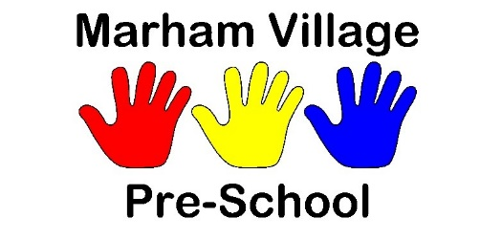
Autumn Reminders
First of all, we break up on Wednesday 19th October for our half term holiday. We return on Monday 31st October.
If your child is in on a Monday, they are very welcome to dress up on Halloween, the first day back. Also on the Monday, we will be having a raffle for a Halloween cake donated by Saran’s cakes (well worth winning!). Tickets will be £1 each and we will draw the raffle at midday on Monday 31st. If your child isn’t in that day, you can still join in by buying tickets in advance or by bank transfer.
Thank you very much to everyone who donated to Katy’s blue day for the Mind charity, we made £70!
Our individual preschool photographs will be taken on the morning of Friday 4th November, so they will be back in plenty of time for Christmas. If you would like to bring in siblings, or even the whole family, just let us know.
On Sunday 6th November, we will be presenting the pub quiz at the King’s Arms in Shouldham to raise money for the preschool. It starts at 7pm and costs £2.50 per person, it would be great to see some of you there. It won’t be too hard, we promise!
Just a couple of ongoing reminders: we are still getting lunch bags, coats, wellies etc without names on them. Please name EVERYTHING that your child brings in.
Please make sure that you do not park in the staff car park, or in front of the school gates when you drop off or pick up your child. Parking is around Hillside, but please consider the residents.
The weather is changing quickly, so please make sure that your child always has appropriate (named!) clothing with them, as we do go outside every day.
Have a lovely half term holiday!

