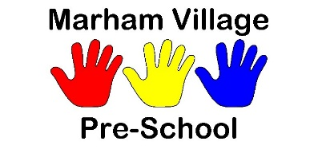
CHRISTMAS 2022 NEWSLETTER
Just a few reminders for the next couple of weeks. Firstly, as most of you know, we are having a stall at the Marham Christmas Fete at Marham Bowls Club this Sunday 4th December from 11am till 3pm. We will be doing face painting and having a tombola. Any last-minute prize donations are greatly appreciated. We’d love to see
you there.
We are also having a tombola stall at the opening of the new play park in Shouldham on Saturday 17th December, from 12 – 3pm. This should be a good day with plenty to do for the children.
Our raffle is up and running, tickets are available to buy and if you’d like to take some to sell to friends and family that would be great. We have some lovely prizes; I will get a list together now that most of them are in.
Our last day of term is on Friday 16th December, and we finish at 1.30pm on that day. We will be having a Christmas party with a visit from Father Christmas, games and party food. We are asking parents to bring a plate of food in, we have a list so that you can choose what you would like to bring.
Also, if Friday isn’t the usual day for your child, they are still very welcome to come to the party, just let us know whether you would like to swap their days on that week or if you would like them to do an extra day.
We return to preschool on Wednesday 4th January.
Have a wonderful Christmas and New Year!

