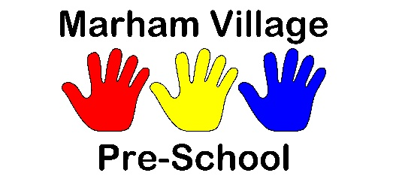
The Annex, Cherry Tree Academy Marham Junior, Hillside, Marham, PE33 9JJ
marhamvillagepreschool@hotmail.com
07950753877

04 Health procedures
04.4 Allergies and food intolerance
When a child starts at the setting, parents are asked if their child has any known allergies or food intolerance. This information is recorded on the registration form.
- If a child has an allergy or food intolerance, 01.1a Generic risk assessment form is completed with the following information:
- the risk identified – the allergen (i.e. the substance, material or living creature the child is allergic to such as nuts, eggs, bee stings, cats etc.)
- the level of risk, taking into consideration the likelihood of the child coming into contact with the allergen
- control measures, such as prevention from contact with the allergen
- review measures
- 04.2a Health care plan form must be completed with:
- the nature of the reaction e.g. anaphylactic shock reaction, including rash, reddening of skin, swelling, breathing problems etc.
- managing allergic reactions, medication used and method (e.g. Epipen)
- The child’s name is added to the Dietary Requirements list.
- A copy of the risk assessment and health care plan is kept in the child’s personal file and is shared with all staff and is also kept in the cook’s Food Allergy and Dietary Needs file.
- Parents show staff how to administer medication in the event of an allergic reaction.
- Generally, no nuts or nut products are used within the setting.
- Parents are made aware, so that no nut or nut products are accidentally brought in.
- Any foods containing food allergens are identified on children’s menus.

Oral Medication
- Oral medication must be prescribed or have manufacturer’s instructions written on them.
- Staff must be provided with clear written instructions for administering such medication.
- All risk assessment procedures are adhered to for the correct storage and administration of the medication.
- The setting must have the parents’ prior written consent. Consent is kept on file.
For other life-saving medication and invasive treatments please refer to 04.2 Administration of medicine.

